Shell Programming: Basic of shell programming, various types of shell, Shell Programming in bash, conditional & looping statement, case statements.
Shell scripting is a powerful tool in Linux that allows users to automate repetitive tasks, manage files, and customize their command-line environment. A shell script is essentially a file containing a series of commands that the shell can execute sequentially.

Basic Syntax and Operations: -

    - Variables

Variables in bash are defined using the

syntax: - variable_name=value

To access the value of a variable, prefix it with $.
Write a code to show the use of a variable.

echo “Hello World”
echo “Write your name”
read person
echo “Hello, $person”

Types of Shell :

- The Bourne Shell (sh)
Developed at AT&T Bell Labs by Steve Bourne, the Bourne shell is regarded as the first UNIX shell ever. It is denoted as sh. It gained popularity due to its compact nature and high speeds of operation.
- The GNU Bourne-Again Shell (bash)
More popularly known as the Bash shell, the GNU Bourne-Again shell was designed to be compatible with the Bourne shell. It incorporates useful features from different types of shells in Linux such as Korn shell and C shell.
- The C Shell (csh)
The C shell was created at the University of California by Bill Joy. It is denoted as csh. It was developed to include useful programming features like in-built support for arithmetic operations and a syntax similar to the C programming language.
- The Korn Shell (ksh)
The Korn shell was developed at AT&T Bell Labs by David Korn, to improve the Bourne shell. It is denoted as ksh. The Korn shell is essentially a superset of the Bourne shell.
- The Z Shell (zsh)
The Z Shell or zsh is a sh shell extension with tons of improvements for customization. If you want a modern shell that has all the features a much more, the zsh shell is what you’re looking for.

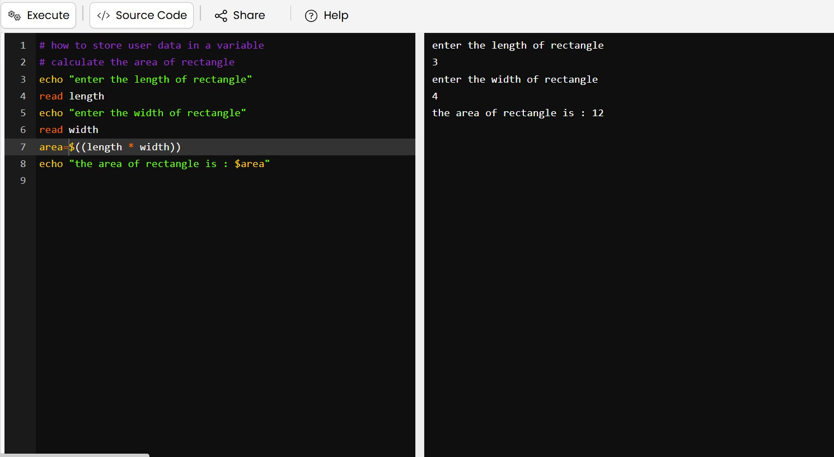
Write a code to calculate the area of rectangle

  - Arithmetic Operations

Bash supports basic arithmetic operations such as addition, subtraction, multiplication, division.

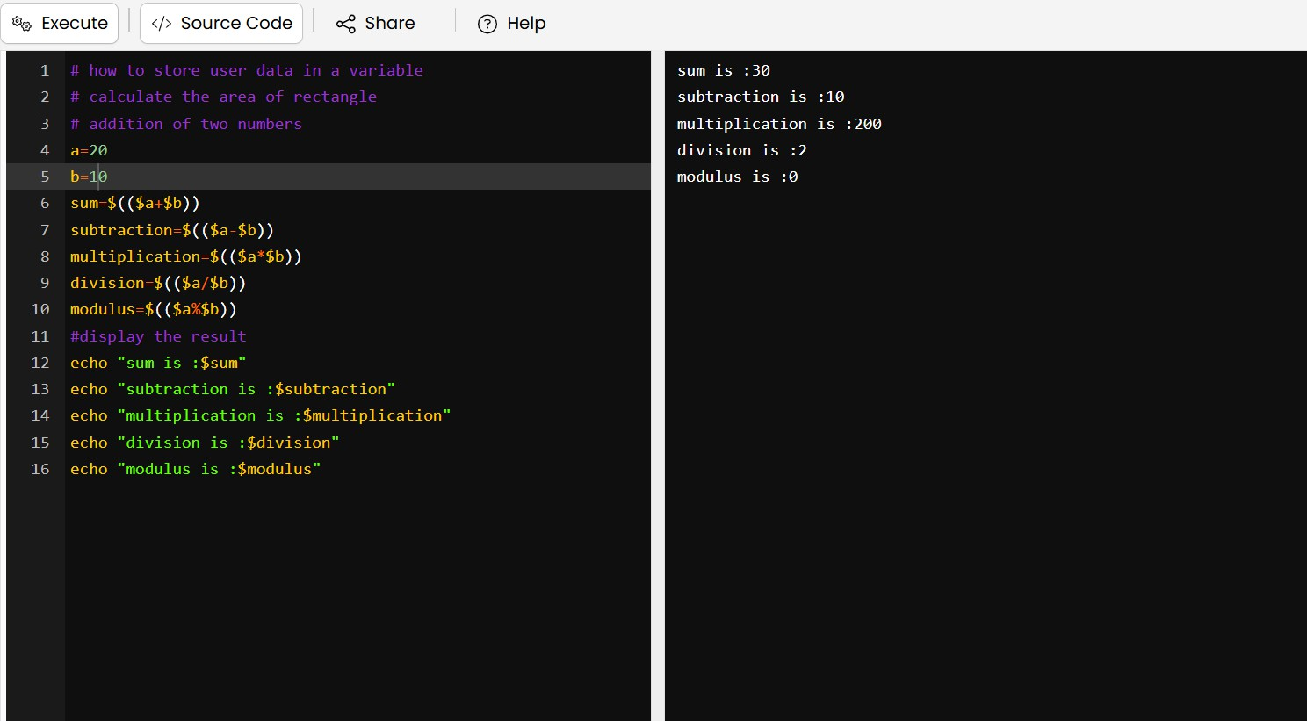

Conditional Statements
- If Statement
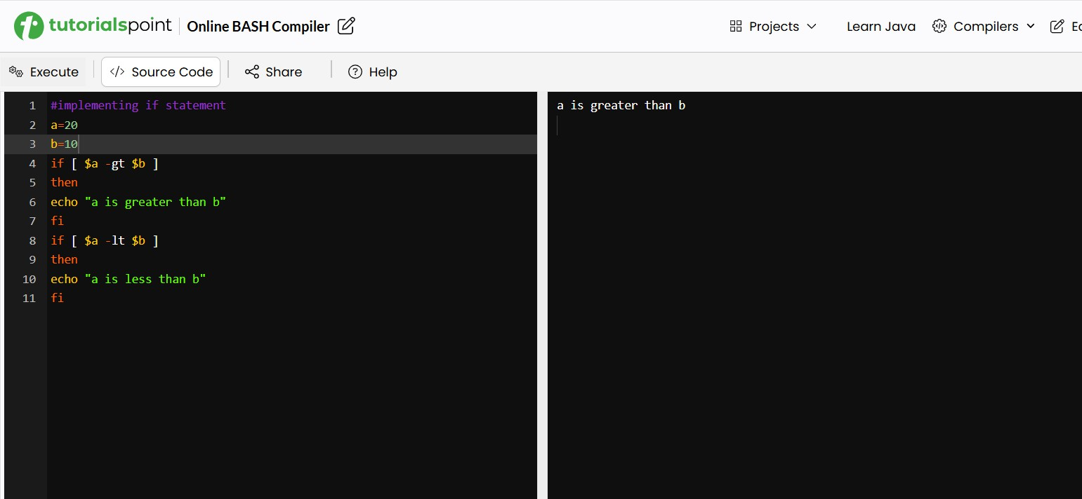
An if statement in Bash is used to make decisions in your script based on conditions.
  - Switch Statement
A switch statement in Bash is typically implemented using the case statement. It allows you to execute different blocks of code based on the value of a variable.

echo "Enter a character: "
read ch
case $ch in
[a-z])
echo "Lowercase alphabet"
;;
[A-Z])
echo "Uppercase alphabet"
;;
[0-9])
echo "Digit"
;;
*)
echo "Special character"
;;
esac

- If – else Statement

If specified condition is not true in If part then else part is execute.

echo "Enter a number:"
read num
if [ $((num % 2)) -eq 0 ]
then
echo "Even Number"
else
echo "Odd Number"
fi

Looping Statements
  - For Loop
The for loop operates on lists of items. It repeats a set of commands for every item in a list.
Some Example of For loop:

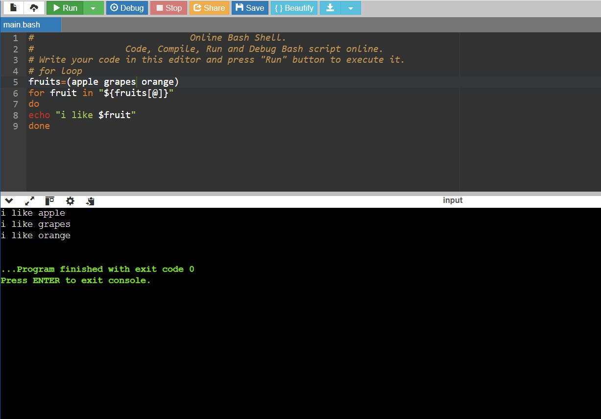

  - Until Loop
The until loop is executed as many times as the condition/command evaluates to false. The loop terminates when the condition/command becomes true.

Some Example of Until loop: -

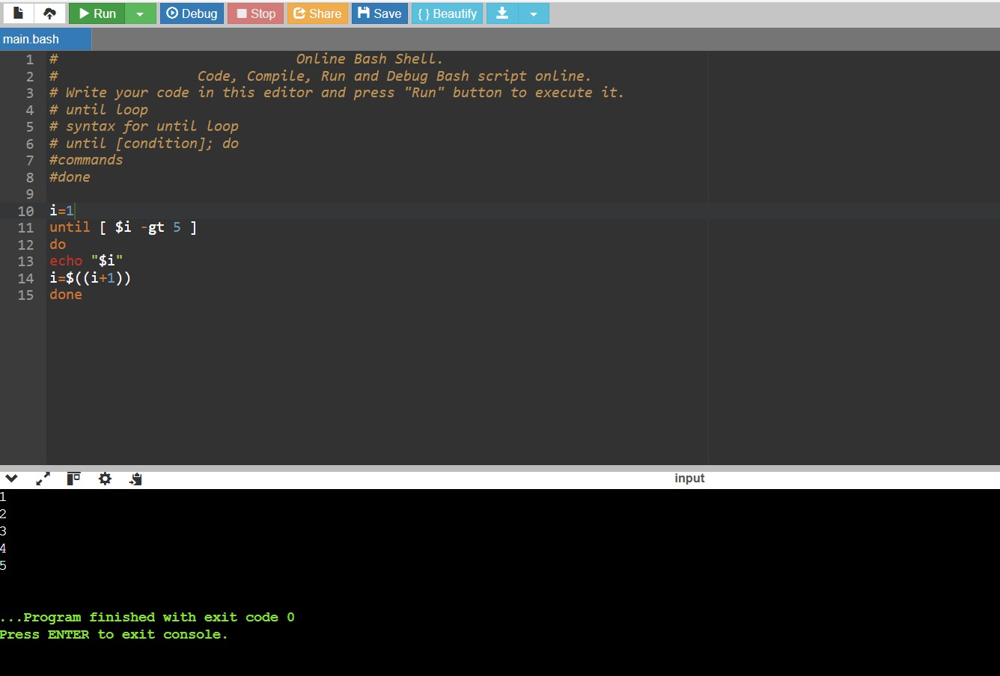

  - While Loop
Here the command is evaluated and based on the resulting loop will execute, if the command is raised to false then the loop will be terminated that.

Code to print the sum of first N numbers:

echo "Enter a number:"
read n
i=1
sum=0
while [ $i -le $n ]
do
sum=$((sum + i))
i=$((i + 1))
done
echo "Sum = $sum”

